## **Source code**

**Quicksort:**

**Using insertion sort for appropriate size small input:**

*def insertion_sort(arr, left=0, right=None):*

*if right is None:*

*right = len(arr) - 1*

*for i in range(left + 1, right + 1):*

*key = arr[i]*

*j = i - 1*

*while j >= left and arr[j] > key:*

*arr[j + 1] = arr[j]*

*j -= 1*

*arr[j + 1] = key*

**Finding the cutoff point between pure insertion sort and pure quicksort:**

*def partition(arr, low, high):*

*pivot = arr[high]*

*i = low - 1*

*for j in range(low, high):*

*if arr[j] < pivot:*

*i += 1*

*arr[i], arr[j] = arr[j], arr[i]*

*arr[i + 1], arr[high] = arr[high], arr[i + 1]*

*return i + 1*

*def quicksort(arr, low=0, high=None):*

*if high is None:*

*high = len(arr) - 1*

*if low < high:*

*pi = partition(arr, low, high)*

*quicksort(arr, low, pi - 1)*

*quicksort(arr, pi + 1, high)*

*# Function to generate random arrays*

*def generate_random_array(n):*

*return [random.randint(0, 20000) for _ in range(n)]*

*# Define small input sizes to test*

*input_sizes = list(range(5, 5000, 5)) # Small inputs from 5 to 5000*

*insertion_times = []*

*quicksort_times = []*

*for size in input_sizes:*

*arr1 = generate_random_array(size)*

*arr2 = arr1.copy()*

*# Measure Insertion Sort Time*

*start = time.time()*

*insertion_sort(arr1)*

*insertion_times.append(time.time() - start)*

*# Measure Quicksort Time*

*start = time.time()*

*quicksort(arr2)*

*quicksort_times.append(time.time() - start)*

*# Find the cutoff point where Insertion Sort becomes faster*

*cutoff_index = np.argmax(np.array(insertion_times) < np.array(quicksort_times))*

*best_cutoff = input_sizes[cutoff_index]*

*print(f"Best Cutoff Point: {best_cutoff}")*

**Implementing randomized pivoting:**

*def randomized_partition(arr, low, high):*

*rand_pivot = random.randint(low, high)*

*arr[high], arr[rand_pivot] = arr[rand_pivot], arr[high]*

*return partition(arr, low, high)*

*def quicksort_random(arr, low, high, cutoff):*

*if high - low + 1 <= cutoff:*

*insertion_sort(arr[low:high + 1])*

*return*

*if low < high:*

*pivot = randomized_partition(arr, low, high)*

*quicksort_random(arr, low, pivot - 1, cutoff)*

*quicksort_random(arr, pivot + 1, high, cutoff)*

**Implementing median-of-three pivoting:**

*def median_of_three_partition(arr, low, high):*

*mid = (low + high) // 2*

*pivots = [(arr[low], low), (arr[mid], mid), (arr[high], high)]*

*pivots.sort()*

*median_index = pivots[1][1]*

*arr[high], arr[median_index] = arr[median_index], arr[high]*

*return partition(arr, low, high)*

*def quicksort_median(arr, low, high, cutoff):*

*if high - low + 1 <= cutoff:*

*insertion_sort(arr[low:high + 1])*

*return*

*if low < high:*

*pivot = median_of_three_partition(arr, low, high)*

*quicksort_median(arr, low, pivot - 1, cutoff)*

*quicksort_median(arr, pivot + 1, high, cutoff)*

**Radix sort**

**Using counting sort as the stable sort of subroutine:**

*def counting_sort(arr, exp):*

*n = len(arr)*

*output = [0] * n*

*count = [0] * 10*

*for i in range(n):*

*index = (arr[i] // exp) % 10*

*count[index] += 1*

*for i in range(1, 10):*

*count[i] += count[i - 1]*

*for i in range(n - 1, -1, -1):*

*index = (arr[i] // exp) % 10*

*output[count[index] - 1] = arr[i]*

*count[index] -= 1*

*for i in range(n):*

*arr[i] = output[i]*

**Parameterizing the radix sort using the base as an input parameter and finding the best base to use for fastest sort:**

*def radix_sort(arr, base=10):*

*max_element = max(arr)*

*exp = 1*

*while max_element // exp > 0:*

*counting_sort(arr, exp)*

*exp *= base*

*# Function to generate random integers*

*def generate_random_array(n):*

*return [random.randint(0, 20000) for _ in range(n)]*

*# Experimenting with different bases for Radix Sort*

*bases = [10, 50, 100, 256, 512, 1024] # Different radix bases*

*radix_times = []*

*for base in bases:*

*arr = generate_random_array(10000) # Fixed input size*

*start = time.time()*

*radix_sort(arr, base)*

*radix_times.append(time.time() - start)*

*# Identify the best base for Radix Sort*

*best_radix_base = bases[np.argmin(radix_times)]*

## **Report**

## **Experimental Setup**

**Processor:** Intel(R) Core(TM) i5-7200U CPU @ 2.50GHz, 2712 Mhz, 2 Core(s)

**Language:** Python

**Random Number Generator:** random.randint() function using random library in Python.

**Optimizations for quicksort and for radix sort:**

For Quicksort, I initially used Insertion sort using small arrays and then compared with pure quicksort to find the optimal cutoff point. After that, I used randomized pivoting and then median of three pivoting to further optimize the process.

For radix sort, I started by using counting sort as a stable subroutine. Then, I iterated over all the possible options to find out the most effective base and used that best base to apply for sorting. This resulted in a more efficient response.

## **Plots**

1. **Plot to find cut off point of insertion sort and quicksort**:

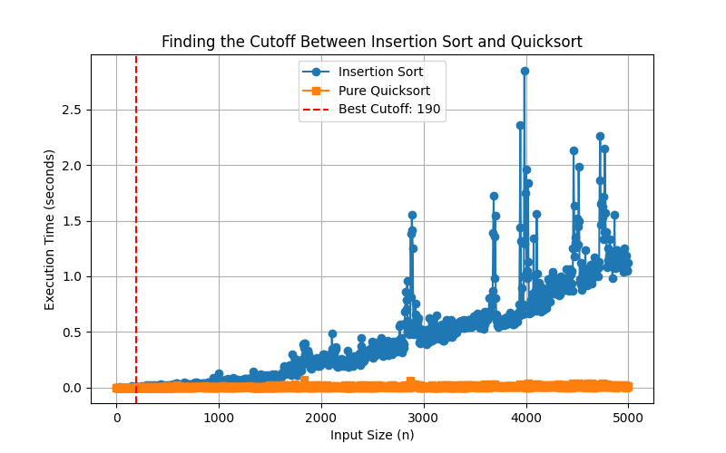

1. **Plot to find the best quicksort among its all variations:**

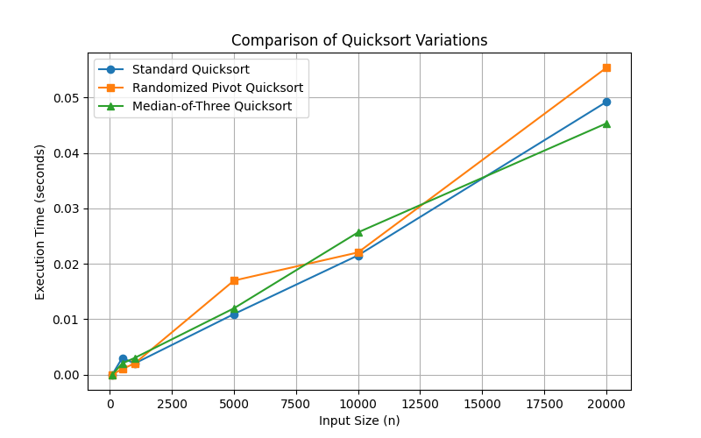

**3. Plot to find the best base to be employed for Radix sort:**

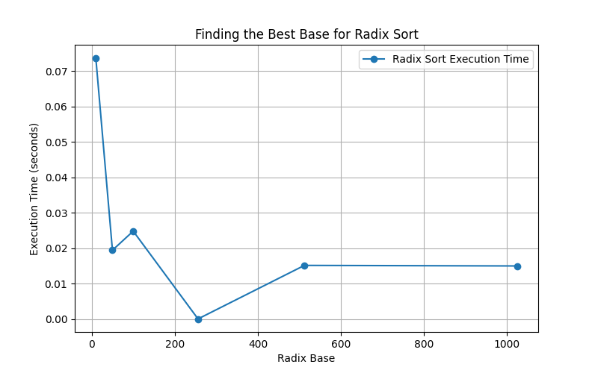

**4(a). Plot to compare best quicksort, insertion sort, and radix sort (input lengths up to 256):**

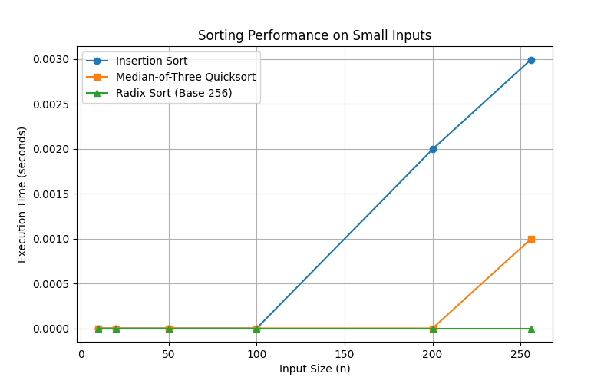

**4(b). Plot to compare best quicksort, insertion sort, and radix sort (with input lengths ranging from 64 up to 214):**

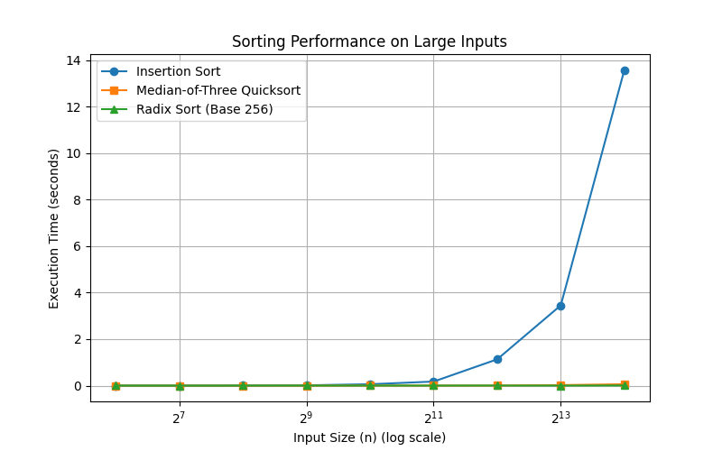

**The average execution times with the plot are given below:**

Average Quicksort Time: 0.007853s

Average Radix Sort Time: 0.005267s

